**SQL Notes**

**KEYWORDS**

WHERE – Limits query by specific criteria

AS – Rename field

ORDER BY – sorts results

ASC – Ascending

DESC - Descending

LIMIT – limits # of results

**Example** – find results of page 3 where each page shows 20 records:

SELECT * from phone_book ORDER BY last_name, first_name LIMIT 20 OFFSET 40

In SQL there's a difference between using single quotes (') and double quotes ("). Single quotes should be used for String literals (e.g. 'lbs'), and double quotes should be used for identifiers like column aliases (e.g. "Max Weight"):

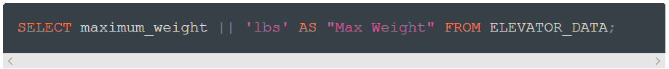

**FUNCTIONS**

|| - Concatenate operator

Join two fields together

EXAMPLE:

SELECT first_name || " " || last_name || " <" || email ||">" AS "to_field" from patrons

LENGTH – returns the length of the field in # of characters